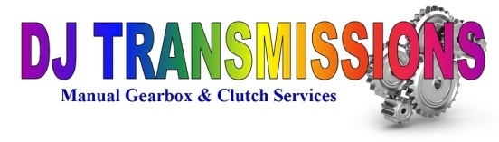 |  | Repair Form
DESCRITION OF FAULTS (Customer Diagnosis)
DJ Transmissions  Unit E5, Greenwood Court Ind Est, Cartmel Drive,  Shrewsbury, SY1 3TB…… 01743817148/01952303012  daz@djtransmissions.com |  | Date: March 7, 2023  Gearbox ID Number #
Customer Name :

DJ Transmissions will deal with the faults listed above, any further issues found during strip down will be advised via telephone and authorization for completing any additional work will be sought. DJ Transmissions will take no responsibility and will not uphold any warranty claim for gearboxes fitted elsewhere and therefore take no responsibility for any damage caused due to poor handling or fitting of gearbox. All gearboxes that leave DJ Transmissions premises will be dry of oil therefore DJ Transmissions take no responsibility for the unit not being refilled with the correct fresh oil once refitted to vehicle.

Signed (Customer):

